
Frontiers of Information Technology & Electronic Engineering
www.jzus.zju.edu.cn; engineering.cae.cn; www.springerlink.com
ISSN 2095-9184 (print); ISSN 2095-9230 (online)
E-mail: jzus@zju.edu.cn

Example of using FITEE Word template*

Ziyang ZHAI^{†1}, Xianliang HU^{†‡2}
¹Editorial Office of Journal of Zhejiang University-SCIENCE, Hangzhou 310027, China
²Department of Mathematics, Zhejiang University, Hangzhou 310027, China
†E-mail: jzus_zzy@zju.edu.cn; xlhu@zju.edu.cn
Received Jan. 6, 2010; Revision accepted Apr. 10, 2010; Crosschecked May 8, 2010

Abstract: This brief sample introduces the aim & scope, database information, and online submission of Frontiers of Information Technology & Electronic Engineering (FITEE for short), and shows the different paper formats at the two stages of ‘manuscript preparation’ and ‘revision & acceptance’. The logos and homepage of the three sibling journals JZUS(A/B) and FITEE are also included.

Key words: Manual; Word template; Frontiers of Information Technology & Electronic Engineering
https://doi.org/10.1631/FITEE.1000000 CLC number:

1 Introduction of FITEE

Aim & scope:
FITEE (former title: Journal of Zhejiang University-SCIENCE C (Computers & Electronics)), is an international peer-reviewed journal. It covers research in Computer Science, Electrical and Electronic Engineering, Information Sciences, Automation, Control, Telecommunications, as well as Applied Mathematics related to Computer Science.
Database information:
FITEE has been accepted by Science Citation Index-Expanded (SCI-E), Ei Compendex, DBLP, IC, Scopus, JST, CSA, etc.
Launched by:
Chinese Academy of Engineering (http://en.cae. cn/ en/) with Zhejiang University
Published by:
Springer & Zhejiang University Press
Online submission:
www.editorialmanager.com/zusc/
2 Paper format
2.1 Preparing manuscript
The electronic manuscript should be prepared to accord with the following (see also http://www.zju. edu.cn/jzus/manuscript.htm):
Title and by-line: Name, affiliation (institution) of the author(s), city, zip code, country, and e-mail address of the author(s) should be given.
Abstract: About 150–250 words should outline the objective, method, main results, and conclusions without mathematical equations or citations.
Key words: Provide 3–6 key words or phrases for cross-indexing this article.
Text: The text should contain an Introduction that puts the paper into proper perspective for the reader, and should also contain Methods, Results, Discussion, and Conclusions sections.
Acknowledgements: Individuals or units other than authors who were of direct help in the work should be acknowledged by a brief statement following the text.

‡ Corresponding author
* Project supported by the National Natural Science Foundation of China (No. xxxxxxxx)
ORCID: Ziyang ZHAI, https://orcid.org/xxxx-xxxx-xxxx-xxxx; Xianliang HU, https://orcid.org/xxxx-xxxx-xxxx-xxxx
© Zhejiang University Press 2021
References: Only essential references (journal article, book, thesis, report, proceedings, etc.) cited in the text (in Author-Year format) can be listed in alphabetical order by author’s surname.
2.2 Revision & acceptance
2.2.1 Figures
Format: At the revision stage, authors who have created their files using a drawing or painting program such as Visio, Origin, Excel, AutoCAD, Coreldraw should provide the original files that can be edited. Authors who have created their files using a drawing or painting program should export the files to TIFF, EPS, PSD, RAW, etc. format. Matlab figures are expected to be exported to EMF format. The figure’s magnification should be expressed by scale bars.
Resolution: Adequate figure resolution is essential to a high-quality print and online rendering of your paper. Raster line art should carry an absolute minimum resolution of 600 dots per inch (dpi).
Line width: The line width should generally be no less than 0.25 pt; the common line widths are 0.5/0.75 pt. Please note that the actual line width changes with the scale of the figure. In different software, we recommend the following line widths: Visio: –03; Origin: –1.5; Matlab: –1.5 pt, etc.
Figures must be numbered consecutively with Arabic numerals, and each figure must be placed in the text following the paragraph in which it is first mentioned. A caption giving the figure number and a brief description must be included. The caption should be understandable without reference to the text. Figures should be cited in the text using the following format: Fig. 1, Fig. 1a, Figs. 1 and 2, Figs. 1–3, or Figs. 1a–1c.
There will be an extra charge for those graphics considered for publication in color. Authors are expected to use different line types to distinguish the different parts of a figure that they do not want to have published in color.
2.2.2 Tables
Tables should usually contain three horizontal lines. Do not use vertical lines. Each table must have a

Table 1 Results for face and eye detection processing using a Pentium IV 2.2 GHz CPU* (Deniz et al., 2010)
Detector | TD (%) |  |  |  | FD (%) |  |  |  | Processing time (ms)
Detector | Faces | Left eye | Right eye |  | Faces | Left eye | Right eye |  | Processing time (ms)
Rowley | 89.27 | 77.51 | 78.18 |  | 2.16 | 0.80 | 1.00 |  | 422.4
Viola-Jones | 97.69 | 0.00 | 0.00 |  | 8.25 |  |  |  | 117.5
ENCARA2 | 99.92 | 91.83 | 92.48 |  | 8.07 | 4.04 | 3.33 |  | 45.6
* Taken from Castrillón et al. (2007). TD: correct detection ratio; FD: false detection ratio

brief title that describes its contents. The title should be understandable without reference to the text. Details such as explanatory material, specific entries, and definitions of non-standard abbreviations should be put in table footnotes, not in the title. In setting up tables, authors should keep in mind the area of the Journal’s page (16.4 cm ×22.8 cm) and the column width (8.0 cm) and should make tables conform to the limitations of these dimensions.
All tables must be mentioned in the text in consecutive order and must be numbered with Arabic numbers. Tables should be cited in the text using the following format: Table 1, Tables 1 and 2, or Tables 1–3.




Fig. 1 Logos of Journal of Zhejiang University- SCIENCE A (Applied Physics & Engineering) (a), Journal of Zhejiang University-SCIENCE B (Biomedicine & Biotechnology) (b), and Frontiers of Information Technology & Electronic Engineering (c)
(a)
(b)
(c)

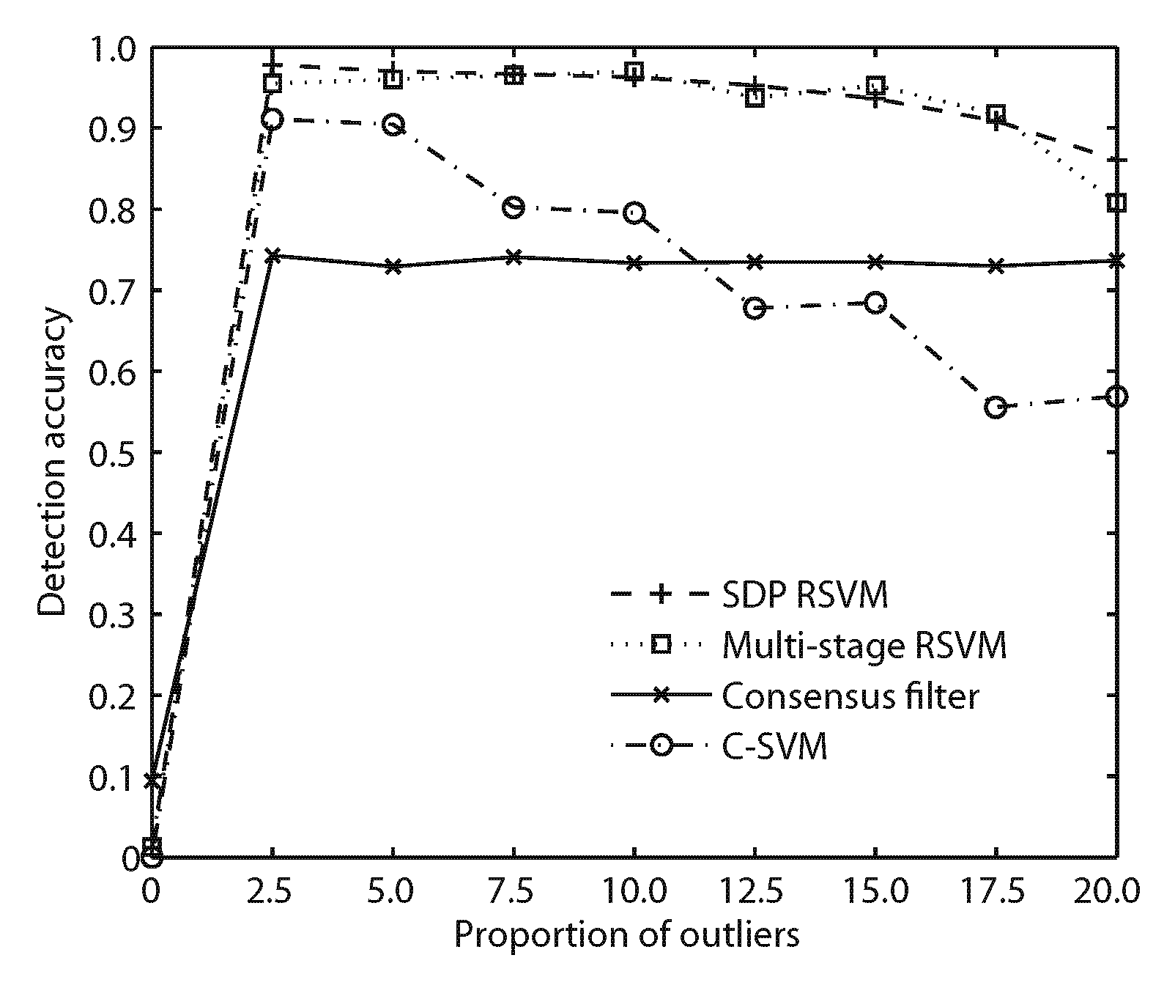
Fig. 2 Comparison of different methods in terms of outlier detection accuracy (Zhou et al., 2011)

Table 2 Video sequences used in the experiments, ordered by increasing head motion* (Deniz et al., 2010)
Video sequence | Number of frames | Average distance | Variance position
1 | 126 | 42.7 (1.6) | 8.2
2 | 175 | 42.9 (2.2) | 11.1
3 | 176 | 44.1 (1.8) | 11.3
4 | 148 | 40.0 (2.8) | 27.1
5 | 119 | 42.9 (2.8) | 37.7
6 | 129 | 42.9 (4.4) | 120.8
7 | 208 | 41.6 (3.1) | 164.4
* Taken from images captured by camera 1

2.2.3 Variables and formulae
Variables, regardless of the context (formula, figure, or table), should be in Italics (e.g., x₁); if a variable represents a vector or a matrix, it should be in Italics & Bold (e.g., x₁). Numerals and operators should never be italicized unless they are components of a variable. The following are some typical equations (Theodoridis et al., 2011):

(1)
(2)
≤0. (3)

2.2.4 Theorem, algorithm and other environments
Definition 1 (Definition title here) This is an illustration of a definition.
Example 1 (Lemma title here) This is an illustration of an example.
Lemma 1 This is a lemma.
Experiment 1 This is an experiment.
Theorem 1 (Theorem title here) This is a theorem.
Theorem 2 (Theorem 2 title here) This is an illustration of Theorem 2.
The following is a sample algorithm: Algorithm 1 (Xu and Zhu, 2011).
Algorithm 1 Example of an algorithm
Input: some thing
Output: something
1 while some condition holds do
2 carry out some processing
3 if some condition is true then
4 do some processing
5 else if some other condition is true then
6 do some different processing
7 else
8 do the default actions
9 end if
10 end while
11 for i=0 to 10 do
12 carry out some processing
13 end for
14 repeat
15 carry out some processing
16 until some condition is met

2.2.5 References & text citation
The reference list provides complete information of the author-date citation in English and lists in alphabetical order of authors’ surnames.
References with more than 10 authors must list the first 10 authors, followed by et al. The references mentioned in the text should accord with the reference list. For a reference published other than in English, the language used should be noted at the end of the reference list, e.g., ‘(in Chinese)’. The publisher and place of publication should be given for a book or proceedings. The DOI (refer to http://www.doi.org) should be provided if it is available.
• For journal articles (Kampf et al., 2002; Tanner et al., 2003; Yu and Wang, 2010)
• For whole books/monographs (Gregersen, 2006) or chapters in edited books (Prigogine, 1976)
• For a proceeding (Gorini et al., 2006)
• For a master or PhD dissertation (Rizvi, 2006)
• For a report (Sweeney, 2000)
• For a preprint (Wu et al., 2008)
• For a patent (Cookson, 1985)
• For a standard (ISO, 1982)
• For an electronic material (University of Sheffield Library, 2001)
For details, see ‘Reference list examples’ at http://www.jzus.zju.edu.cn/revacc.htm\#1
Contributors (refer to https://www.casrai.org/credit.html)
Zi-yang ZHAI designed the research. Zi-yang ZHAI and Xian-liang HU processed the data. Zi-yang ZHAI drafted the manuscript. Xian-liang HU helped organize the manuscript. Zi-yang ZHAI and Xian-liang HU revised and finalized the paper.

Compliance with ethics guidelines
Zi-yang ZHAI and Xian-liang HU declare that they have no conflict of interest.

References
Cookson AH, 1985. Particle trap for compressed gas insulated transmission systems. US Patent, 4554399.
Deniz O, Castrillon M, Lorenzo J, et al., 2010. Computer vision based eyewear selector. J Zhejiang Univ-Sci C (Comput & Electron), 11(2):79-91.
https://doi.org/10.1631/jzus.C0910377
Gorini S, Quirini M, Menciassi A, et al., 2006. A novel sma-based actuator for a legged endoscopic capsule. First IEEE/RAS-EMBS International Conference on Biomedical Robotics and Biomechatronics, p.443-449.
https://doi.org/10.1109/BIOROB. 2006.1639128
Gregersen H, 2006. Biomechanics of the gastrointestinal tract. People’s Medical Publishing House, Beijing, China, p.216-236.
ISO, 1982. Steels-classification-part 1: Classification of steels into unalloyed and alloy steels based on chemical composition, ISO 4948-1:1982. International Organization for Standardization, Geneva.
Kampf SK, Salazar M, Tyler SW, 2002. Preliminary investigations of effluent drainage from mining heap leach facilities. Vadose Zone J, 1(1):186-196.
http://www.vadosezonejournal.org
Prigogine I, 1976. Order through fluctuation: Self-
organization and social system. In: Jantsch E, Waddington C (Eds.), Evolution and Consciousness: Human Systems in Transition. Addison-Wesley, London, p.93-134.
Rizvi UH, 2006. Combined multiple transmit antennas and multi-level modulation techniques. MS Thesis, Royal Institute of Technology, Stockholm, Sweden (in Swedish).

Sweeney L, 2000. Uniqueness of simple demographics in the U.S. population. Technical Report, No. LIDAP-WP4. Laboratory for International Data Privacy, Carnegie Mellon University, PA.
Tanner NA, Wait JR, Farrar CR, et al., 2003. Structural health monitoring using modular wireless sensors. J Intell Mater Syst Struct, 14(1):43-56.
https://doi.org/10.1177/1045389X03014001005
Theodoridis D, Boutalis Y, Christodoulou M, 2011. Direct adaptive regulation of unknown nonlinear systems with analysis of the model order problem. J Zhejiang Univ-Sci C (Comput & Electron), 12(1):1-16.
https://doi.org/10. 1631/jzus.C1000224
University of Sheffield Library, 2001. Citing electronic sources of information. Available from http://www.shef. ac.uk/library/libdocs/hsl-dvc1.pdf [Accessed on Feb. 23, 2007].
Wu Z, An Y, Wang Z, et al., 2008. Study on zoelite enhanced contact-adsorption regeneration-stabilization process for nitrogen removal. J Hazard Mater, in press.
https://doi.org/10.1016/j.jhazmat.2007.12.029
Xu HH, Zhu J, 2011. An iterative approach to Bayes risk decoding and system combination. J Zhejiang Univ-Sci C (Comput & Electron), 12(3):204-212.
https://doi.org/10.1631/jzus.C1000045
Yu L, Wang JP, 2010. Review of the current and future technologies for video compression. J Zhejiang Univ-Sci C (Comput & Electron), 11(1):1-13.
https://doi.org/10.1631/jzus.C0910684
Zhou XC, SHEN, H.B., YE, J.P., 2011. Integrating outlier filtering in large margin training. J Zhejiang Univ-Sci C (Comput & Electron), 12(5):362-370.
https://doi.org/10.1631/jzus.C1000361

Appendix: Appendix title

Appendix.

